UR PERCENTILE
Visit : http://groups.yahoo.com/group/urpercentile/
Preparing for entrance exam for top Management Institute ?
Join Us.

LESSON P1048 Time Limit : 20 Minutes
http://groups.yahoo.com/group/urpercentile/

Q1 To Q6 is based on the graph below which shows the exchange rate of Q$,Y$ and P$ compared to INR during 12 months of a year.

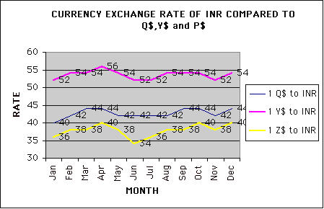

Q1. A Man has INR 50,000. He buys Q$ in Jan and sell the same in Oct to get INR and buys Z$ out of the proceeds. How many Z$ does he get ?

Q2. Which currency when compared to INR showed the maximum increase from start of the year till the end of year, in terms of percentage?

Q3. A man has INR 500,000. What was the best he could have earned if he had option to convert it to other currency and back only once during the year?

Q4. Exchange rate of Q$ to Y$ is given by the formula (1 Q$ to INR/ 1Y$ to INR). If a person exchanges Q$ 100,000 to Y$ in May, how many Y$ will he get?

Q5. Which currency compared to INR remained stable for longest duration and when?

Q6. What is the average exchange rate of Y$ to INR for the year ?
http://groups.yahoo.com/group/urpercentile/

Q7 to Q12 are based on the following chart which represents the amount of water filled or drained by three Pipes in corresponding time. As you can make out Pipe 1 and Pipe 2 are inlet pipe and Pipe 3 is a drain pipe.

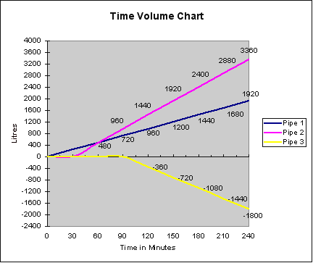

Q7. If all the 3 pipes are working , as represented in the graph, after how many minutes a tank of 2,400 liters will start overflowing ?

Q8. If only Pipe 1 and Pipe 2 are working as per the graph timing and Pipe 3 is not activated how long will it take to fill a 2400 Liter tank ?

Q9. After how many minutes of the start of Pipe 2 did pipe 3 start functioning?

Q10. If a tank of Capacity 4,800 liters is full and Pipe 3 starts its action, how long will it take to drain the tank out?

Q11. If all the three pipes start working at the same time how long will they take to fill a tank of 1,200 Liters ?

Q12. If only Pipe 2 and Pipe 3 are working on a 100 Liters tank, how long will they take to fill it ?

http://groups.yahoo.com/group/urpercentile/

Q13 to Q 18 are based on the graph below which represent the location of 4 cars at different times. Two of the Cars are traveling from Delhi, while two cars are traveling towards Delhi .

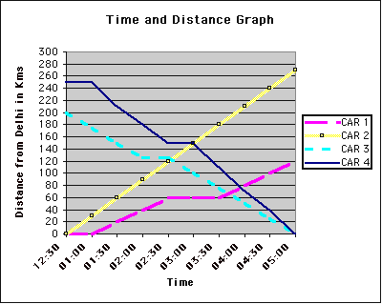

Q13. What is the distance between the two cities from where Car 3 and Car 4 start their journey towards Delhi?

Q14. Which Car took no halt in between and which car took the halt for maximum duration ?

Q15. Which car had the maximum average speed?

Q16. How many hours did Car 4 took to reach Delhi after starting its journey?

Q17. How many Cars of Car 1, Car 3 and Car 4 did Car 2 meet during the journey?

Q18. Car 2 has to reach a destination 360 Kms from Delhi. At what time will it reach its destination if it continues to travel at the speed it traveled first 100 Km ?

.
http://groups.yahoo.com/group/urpercentile/

MATCH THE WORDS IN SET A WITH THEIR MEANINGS IN SET B

SET A Q19. Propinquity, Q20. Serried, Q21. Astigmatism , Q22. Iniquity, Q23. Chicanery, Q24. Toilsome.

SET B
A. Requiring hard work.
B. Exceptionally brave.
C. Crowded.
D. Deception especially by manipulation of language.
E. A visual defect which prevents proper focus.
F. Eat or drink too much.
G. Sabotage.
H. To get nervous due to lack of experience.
I. To steal somebody's property.
J. Perceptible by touch.
K. A gross immoral act or injustice.
L. Nearness in space time or relationship.

http://groups.yahoo.com/group/urpercentile/

ANSWERS :

Ans1. He buys Q$ at rate of 40. so 50,000/40= 1,250.
He sells at rate of 44 so he gets 44*1,250= INR 55,000. With 55,000 he buys Z$ at rate of 40 so he gets , 1,375 Z$.

Ans 2. Q$ = 54*100/52= 103.84 %, Y$ = 44*100/40=110 %. Z$= 40*100/36= 111.11 %. So Z$ showed the maximum increase.

Ans 3. To earn the maximum possible he has to buy when the price is minimum and sell when price was the maximum.
Checking for the three currency:
Q$ : Minimum price= 40 and maximum price =44. 500,000*44/40 =550,000
Y$ : Minimum Price= 52 and maximum price = 56. 500,000*56/52=538,461
Z$ : Minimum price = 34 and maximum price = 40. 500,000*40/34= 588,235
So he could have earned maximum had he bought Z$ when it was at 34 and sold the proceed when the exchange rate was 40.

Ans 4. 100,000*42/54 = 77,777.77

Ans 5. Q$ remained stable for longest duration from May to August.

Ans 6. Take assumed mean = 54 . Calculating the variance of each we get :
-2+0+0+2+0-2-2+0+0+0-2+0= -6. –6/12 = -.5 . So the mean =54-.5= 53.5

Ans 7. We see at 150 minutes, the sum effect of the pipe is 1920+1200-720=2,400. So after 150 minutes the tank will start overflowing.

Ans 8. At 120 minutes the sum effect of Pipe 1 and Pipe 2 is 1,440+960=2,400. So at 120 minutes Pipe1 and Pipe2 will fill the tank.

Ans9. From X axis we can make out that Pipe 2 started after 30 minutes and Pipe 3 started after 90 minutes. So Pipe 3 started 60 minutes after Pipe2.

Ans 10. From the graph we can make out that Pipe 3 drains at a rate of 12 Liters per minute ( 360-0/30=12). So to drain 4,800 liters it will take 400 minutes.

Ans 11. From the graph we can make out that Pipe 1 fills at rate of 8 lt per minute, Pipe 2 fills at rate of 16 liters per minute and Pipe 3 drains at rate of 12 lt per minute. If all the 3 pipes are open , 8+16-12= 12 liters will be filled every minute. So to fill 1,200 liters 100 minutes will be required.

Ans 12. Pipe 2 fills at rate of 16 liters per minute while Pipe 3 drain 12 liters per minute , so if both are working they will fill 4 liters per minute. So to fill 100 liters tank they will take 25 minutes to fill.

Ans 13. Cannot be determined. We have no information about the direction from which the cars are coming from. They could be coming from different directions.

Ans 14. A Flat line indicates a halt. Car 1 took maximum halt from 2:00 to 3:00. Car 2 didn’t take any halt.

Ans 15 and Ans 16. Car 4 traveled the maximum distance in the least time. It started its journey at 1:00 and covered 250 Kms in 4 hours reaching Delhi at 5:00.

Ans 17. Cannot be determined as we are not aware of the direction in which the four cars are traveling.

Ans 18. Car 2 is traveling at a constant speed of 60 Km per hour. So to cover 360 Km it will take 6 hours. It started it journey at 12:30 so it will reach its destination at 6:30.

Ans 19= L, Ans 20= C, Ans 21= E, Ans 22= K, Ans 23= D, Ans 24= A

http://groups.yahoo.com/group/urpercentile/

